Parking System Application: A Reflection
ICT-4310: Object-Oriented Methods and Programming I

Introduction
This term I built a parking management system using Java and object-oriented programming. The project started small, with just a few classes, and grew week by week into a full application that can register customers, issue parking permits, record parking events, and calculate charges. Coming into this course with no prior programming background, I was not sure I would be able to pull it all together. But by the end, I had something that works. As someone who works in an academic library as a research and instruction assistant, I found this experience unexpectedly relevant to my day job. Just like organizing research resources or helping patrons navigate information systems, building this application taught me that good organization and clear structure make everything easier to use and maintain.

Class Diagram Explanation
The class diagram shows eleven classes divided into three groups. The first group holds simple building blocks: Address, Money, and CarType. These are like the basic fields on a library intake form. They just hold information and get used by everything else. The second group contains the main objects in the system: Customer, Car, ParkingLot, ParkingPermit, and ParkingTransaction. Each one represents something real. A Customer can have multiple Cars. A ParkingPermit connects one Car to one Customer. A ParkingTransaction records what happened when that car parked in a specific lot on a specific day.
The third group is where the work gets done: PermitManager, TransactionManager, and ParkingOffice. PermitManager handles everything related to issuing and tracking permits. TransactionManager keeps a record of all parking events and calculates charges. ParkingOffice is the main class that everything flows through. Instead of doing all the work itself, it passes tasks off to the two managers. This is a lot like how a reference desk works: the librarian at the desk does not personally know every resource in the building, but they know who to send you to. Each part has a clear job, which keeps things from getting messy.
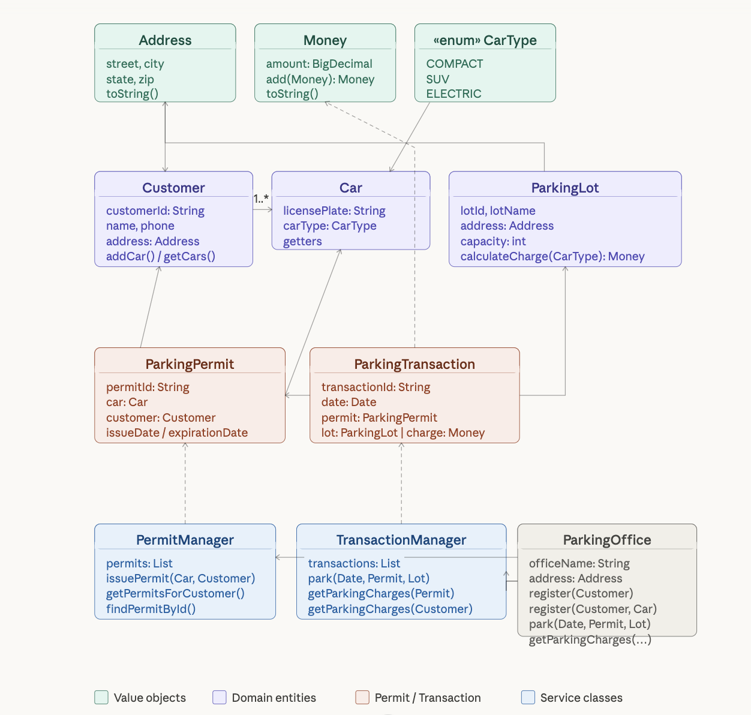

What I Learned
The biggest thing I learned is that programming is really about how things connect, not just how individual pieces work. Early on I was focused on getting each class right on its own. As the project grew, I started to see that the relationships between classes matter just as much. If one class tries to do too many things, it becomes hard to fix, hard to test, and hard to understand. That is a lesson that applies directly to my library work. When we design a research guide or an instruction session, we think about how the pieces fit together for the user, not just whether each piece is technically correct on its own.
I also learned a lot from writing unit tests. At first, testing felt like extra work on top of already writing the code. But it actually helped me catch problems I would have missed otherwise. For example, I had not thought about what should happen if someone tries to register a car for a customer who never signed up in the first place. Writing a test for that scenario made me handle it properly. Testing pushed me to think more carefully about what my code was supposed to do, which made the final product much more reliable.

New Tools and Technologies
Most of the tools in this course were new to me. JUnit 5 was one I had never used before. It gave me a structured way to test my code and showed me clearly when something was broken. Watching tests go from failing to passing as I fixed bugs was satisfying in a way I did not expect. I also used IntelliJ IDEA to write and run my code, which has tools built in for visualizing how classes relate to each other. That kind of visual overview helped me understand my own project better. GitHub was another new tool for me. Using it to save and organize my work felt similar to managing a shared drive or document repository at the library, just with a much more structured version history.

What I Would Have Done Differently
If I were starting over, I would plan more before writing any code. I jumped into building classes before thinking through how they would all fit together, and that cost me time later when I had to go back and reorganize things. A simple sketch of the class diagram at the start would have helped a lot. I also wish I had thought more carefully about the Money class early on. I started with a basic number and later had to rewrite it in a way that caused small bugs in other parts of the project. Starting with a cleaner design from the beginning would have saved a lot of troubleshooting. This is something I can relate to in library instruction: the planning stage is never wasted time.

Future Enhancements
There are several things I would add if I had more time. Right now the system stores everything in memory, so all the data disappears when the program closes. Adding a way to save data to a file or a database would make it usable in a real setting. I would also add logic to check whether a permit has expired before allowing someone to park, since the system issues permits with an expiration date but does not currently check it. Tracking how full each parking lot is in real time would be another useful feature. Looking further ahead, I can imagine applying similar ideas at the library, such as a simple tool to track study room reservations or equipment loans, where the same kind of object-oriented thinking about customers, resources, and transactions would apply directly.

Conclusion
Building this parking system over ten weeks was a challenging but rewarding experience. Coming in with no programming background, I was not sure how far I would get. By the end I had a working application with real logic, passing tests, and a design I can explain and defend. More than that, I came away with a new way of thinking about how systems work and how the pieces of any organized process relate to each other. That kind of thinking is something I can carry into my work as a research and instruction assistant, whether I am helping a patron navigate a database, designing an instruction session, or looking for ways to make library services run more smoothly. This class gave me tools I did not have before, and I plan to keep building on them.

